TASK 1:

#include<stdio.h>

int main(){

int arr[] = {1,2,3,4,5,6,7,8,9};

int sum = 0;

for(int i = 0; i <= 9; i++){

sum += i;

}

printf("Sum is %d", sum);

}

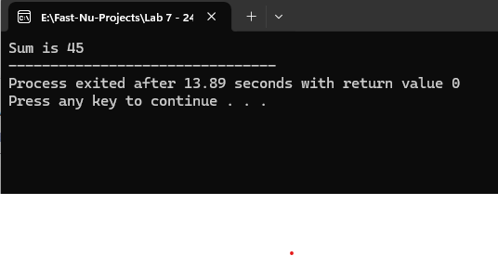

Task 2:

#include<stdio.h>

int main(){

int arr[] = {1,2,3,4,5,6,7,8,9};

int num;

printf("Enter a number: ");

scanf("%d", &num);

for(int i = 0; i <= 9; i++){

if(arr[i] == num){

printf("The number is present");

return 0;

}

}

printf("Number not found");

}

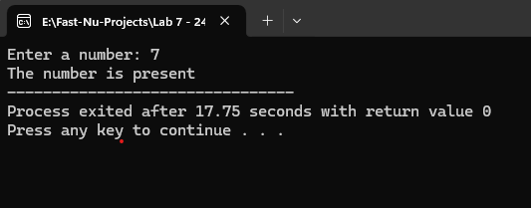

Task 3:

#include<stdio.h>

int main(){

int n;

printf("Enter number of elements: ");

scanf("%d", &n);

int arr[n];

for(int i = 0; i < n; i++){

printf("enter input number %d: ", i + 1);

scanf("%d", &arr[i]);

}

printf("Array in reverse order is: ");

for(int i = n - 1; i >= 0; i--){

printf("%d ", arr[i]);

}

}

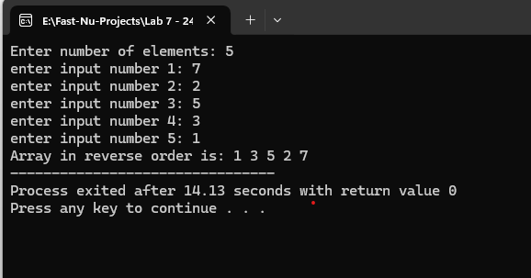  
  
Task 4:

#include <stdio.h>

int main() {

char name[16];

char email[31];

char phone[16];

int validName = 0;

int validEmail = 0;

int validNum = 0;

printf("Enter name (15 characters max): ");

scanf("%15s", name);

printf("Enter email (30 characters max): ");

scanf("%30s", email);

printf("Enter phone number (15 characters max): ");

scanf("%15s", phone);

printf("\n");

// Validate name input

for (int i = 0; name[i] != '\0'; i++) {

if ((name[i] < 'A' || name[i] > 'Z') &&

(name[i] < 'a' || name[i] > 'z') &&

name[i] != ' ') {

printf("Invalid name\n");

validName = 1;

break;

}

}

for (int i = 0; email[i] != '\0'; i++) {

if ((email[i] < 'A' || email[i] > 'Z') &&

(email[i] < 'a' || email[i] > 'z') &&

(email[i] < '0' || email[i] > '9') &&

(email[i] != '.') &&

(email[i] != '_') &&

(email[i] != '-') &&

(email[i] != '@')) {

printf("Invalid Email \n");

validEmail = 1;

break;

}

if (email[i] == '@') {

validEmail = 1;

}

}

if (validEmail == 0) {

printf("Invalid Email. Does not contain '@'\n");

}

else{

printf("valid Email.\n");

}

for (int i = 0; phone[i] != '\0'; i++) {

if ((phone[i] < '0' || phone[i] > '9') &&

(phone[i] != '-') &&

(phone[i] != ' ') &&

(phone[i] != '+')) {

printf("Invalid phone \n");

validNum = 1;

break;

}

if(i != 0 && phone[i] == '+'){

printf("Invalid Number. + sign at wrong place");

validNum = 1;

break;

}

}

if (validNum == 0) {

printf("Valid phone Num");

}

/*

printf("Valid Name: %s\n", name);

printf("Valid Email: %s\n", email);

printf("Phone Number: %s\n", phone);

*/

return 0;

}

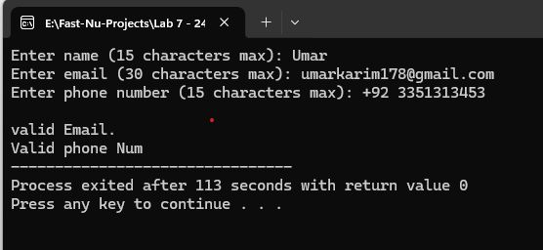

Task 5:

#include<stdio.h>

int main(){

int arr[] = {4,1,6,8,10,21,8,9,2,6};

int min = 32000, max = 0;

for(int i = 0; i < 10; i++){

min = (min > arr[i])? arr[i]: min;

max = (max < arr[i])? arr[i]: max;

}

printf("max number is %d \n", max);

printf("min number is %d \n", min);

}

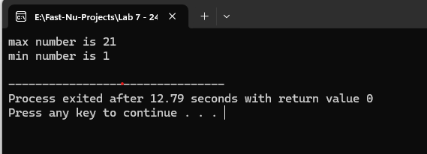

Task 6:

#include<stdio.h>

int main(){

int arr[] = {25, 30, -2, 35, 42, 28, 10};

float avg, sum;

for(int i = 0; i < 7; i++){

if(arr[i] < 0){

printf("day %d had extreme cold \n", i + 1);

}

if(arr[i]>40){

printf("day %d had extreme heat \n", i + 1);

}

sum += arr[i];

}

avg = sum / 7;

printf("average temp is %d", avg);

}

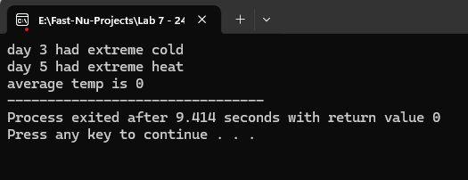  
  
Task 7:

#include<stdio.h>

int main() {

int arr[] = {2, 3, 1, 2, 3};

int n = sizeof(arr)/sizeof(arr[0]);

int i;

printf("Numbers occurring more than once: ");

for (i = 0; i < n; i++) {

int index = arr[i] % n;

if (arr[index] >= n) {

printf("%d ", index);

}

arr[index] += n;

}

printf("\n");

return 0;

}

